**Documentation for *Identity as a Creative Space***

**AKA *Craft Your Magical Identity Being***

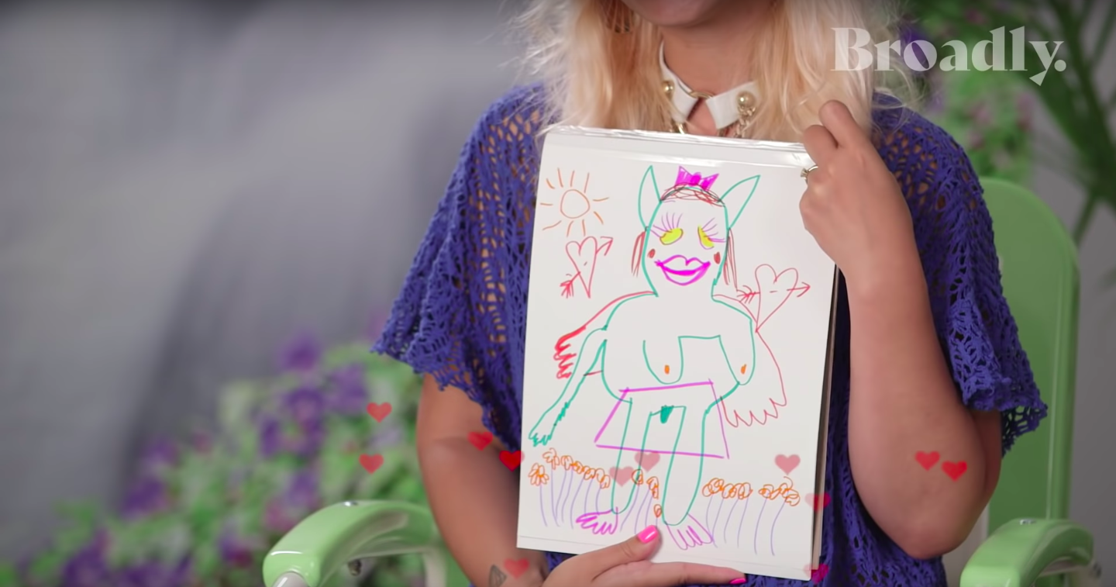

Bunny Michael’s “Spirit Creature” from their interview with Big Freedia for Broadly Hotline.

This workshop is geared toward gender variant kids under the age of 18 and their adults, however any age group and gender identity can gain from it. The purpose of this workshop is to explore the multitudes of features that make us who we are in a creatively liberating way. Attendees will leave with art that describes how they see themselves and with tools to converse with their loved ones about this identity. This workshop at its best should offer a fun and safe way to open discussions about what our identities mean to us.

**Schedule**

A 50 Min run of the workshop should be broken down like this:

INTRODUCTION (10 Minutes)

* Conversation about what identity means
* Brainstorm about the characteristics that are a part of our identity by giving personal examples

ACTIVITY (20 Minutes)

* Create your true internal creatures with an assortment of materials (paper, glue, colored pencils, crayons, clay, etc) in pairs

CONCLUSION (20 Minutes)

* Share your creatures and what led you to create them with the group
* Final notes and goodbyes

If more time, include a free write brainstorming section where attendees can brainstorm their creature’s characteristics before creating them.

**Budget**

(for 15 Individuals)

|  |  |  |  |
| --- | --- | --- | --- |
| Material | Cost | Link | Notes |
| Construction Paper | $5.31 | <https://www.amazon.com/gp/product/B0017OJKLI/ref=ppx_yo_dt_b_asin_title_o01_s02?ie=UTF8&psc=1> |  |
| Markers/Crayons/Colored Pencils | $16.68 | 2X - (<https://www.amazon.com/gp/product/B00NJGAJNU/ref=ppx_yo_dt_b_asin_title_o01_s02?ie=UTF8&psc=1>)  4C - (<https://www.amazon.com/gp/product/B0765ML9Y1/ref=ppx_yo_dt_b_asin_title_o01_s00?ie=UTF8&psc=1>) |  |
| Glue | $5.81 | <https://www.amazon.com/gp/product/B01JZYM6GC/ref=ppx_yo_dt_b_asin_title_o00_s00?ie=UTF8&psc=1> |  |
| Cardboard | $0 |  | Recycle if Possible |
| Clay | $41.94 | 6x assorted colors (<https://www.amazon.com/gp/product/B001UNJN5O/ref=ppx_yo_dt_b_asin_title_o01_s02?ie=UTF8&psc=1>) |  |

Total Cost: ~ $69.74

**Preparation for Workshop**

* Press for workshop
  + Create invite event
  + Send to LGBTQ and Youth art organizations to send to their followings
  + Invite personal community
* Lock in location
* Send out reminders to RSVPs
* Gather Materials
* Create examples
  + You will be able to explain your own example, but consider also having friends create their own identity being and make videos of them explaining their process
* Lock down someone to document the workshop
* Consider how individuals will be bringing their creations home. Do you need to provide boxes or folders? Does your budget allow for that?

**Feedback**

The feedback I received expanded upon the workshop in really nice ways. If offered a few ideas on how to fill in the time if the workshop was to be a bit longer. I think offering a short brainstorming session off of a handout (see example below) would be a great way to ease attendees into the mindset of creative exploration. Also, if budget allows for it, a little to go box or bag would be great as the clay doesn’t dry and you want to have attendees to be able to get their creations home safely.

Example Worksheet:

What are some of your favorite characteristics (internal or physical) about yourself?

What colors and textures do you associate with your identity? Why?

What kind of environments make you feel the most at home?

Rough sketch your Identity Being based off of the above information.

**Photo Documentation**

Here are some images from the workshop held 3/5/2019

